|  |
| --- |
| User Manual  Leave & Attendance Management (Employee) |
| REFERENCE: GW/ERP/USER MANUAL |
|  |
| **Genweb2 Ltd.** |
| **31-Jul-17** |



|  |
| --- |
|  |

Contents

A. Document Information 4

B. Document History 5

C. Introduction: 5

1. User Login 5

1.1 Home Page 5

1.2 Login Page 6

1.3 Log out Page 6

1.4 Edit Profile and Change Password 7

1.5 Website Browse and Back to Home Page 9

2. Leave Request 10

2.1 Create Leave Request 10

2.2 Show Leave Summary 12

2.3 Create Leave Allocation Request 13

3. Short Leave Request 14

3.1 Create Short Leave Request 14

4. Attendance 16

4.1 Create Manual Attendance 16

4.2 Create Alter Rostering 17

5. OT Requisition 19

5.1 Create a OT Request 19

6. Employee 20

6.1 View employee 20

7. Mobile bills 21

7.1 View mobile bills 21

8. Mobile bill limits 21

8.1 View mobile bill limits 21

9. Contracts 22

9.1 View Contracts 22

10. Employee IOU 22

10.1 View employee IOU 22

1. Document Information

|  |  |
| --- | --- |
| Document Name | User manual(General user) |
| Document Author | Rashedul Alam |
| Document Version | 1.1 |
| Release Date |  |

|  |  |
| --- | --- |
| Review by | Matiar Rahman |
| Review Date | Apr 2, 2018 |
| Approved By | Matiar Rahman |
| Approval Date | Apr 2, 2018 |

1. Document History

|  |  |  |  |  |  |
| --- | --- | --- | --- | --- | --- |
| A=Added, M=Modified, D=Delete | | | | | |
| **Version No** | **Date** | **Section No** | **A/M/D** | **Description of Change** | **Author** |
| 1.0 | 25-Jan-2017 |  | A | Initial | Rashedul Alam |
| 1.1 | 2-april -2018 |  | M | Added 8 process. Employee, Employee loan, Mobile bill process, Arrear, Other allowance, Meal bills, Employee configuration, Reports. | Rashedul Alam |
|  |  |  |  |  |  |

# Introduction:

This User manual is to clearly identify the customer requirements and provide a detailed document. This user manual will contain general user related all information. The customer will read this document and get a clear view the HR module. It will also help the review team to validate whether the customer requirements have been fulfilled or not.

# 1. User Login

## 1.1 Home Page

For user login we have to go website home page by using URL: “**http://202.164.208.130:8069**”. Click sign in button and find out login page.

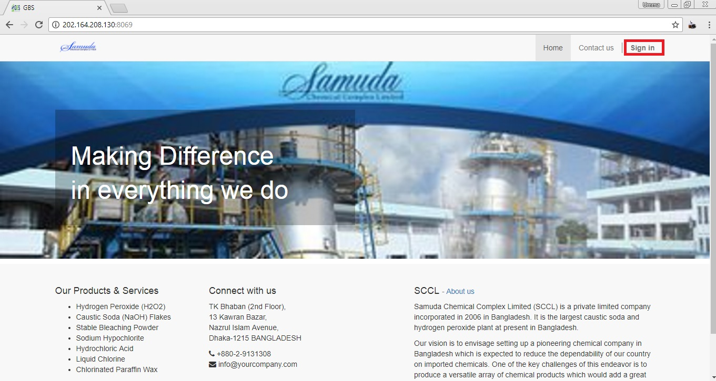

Fig: Home Page

## 1.2 Login Page

After click on sign in button, fill Email and Password -> Click **Log in** button.

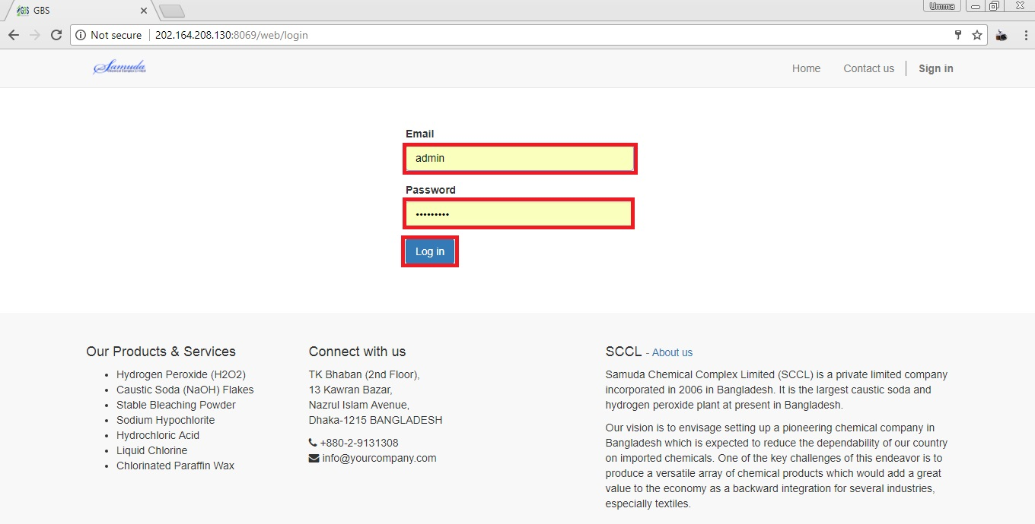

Fig: Login Page

## 1.3 Log out Page

If we want to sign out from website then click **User icon** then find out **Log out** button and click.

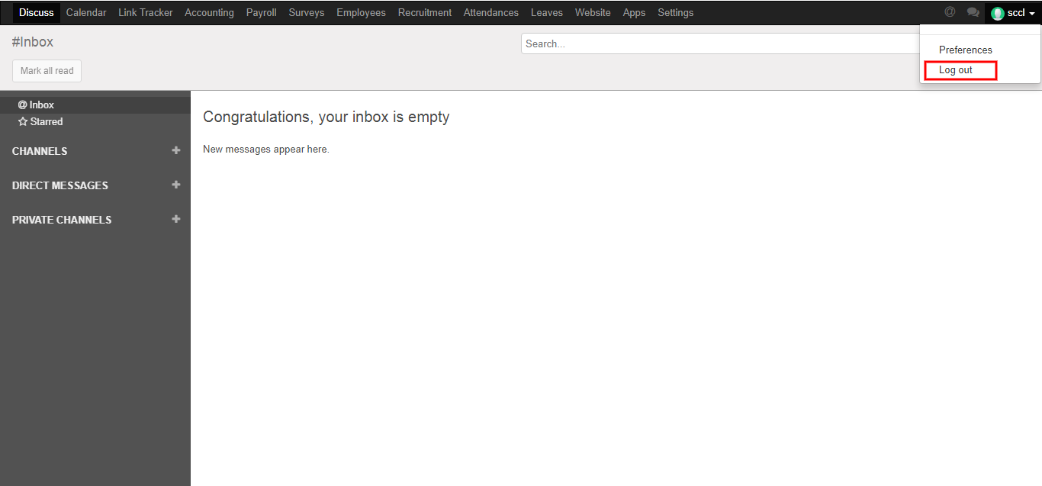

Fig: Logout Page

## 1.4 Edit Profile and Change Password

First we need to click **Preferences** then edit our profile and change our password. After entering the all information click **save**.

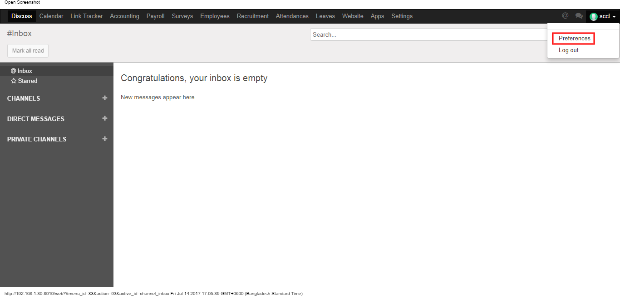

Here we can edit our information what we want. After entering the all information click **save**.

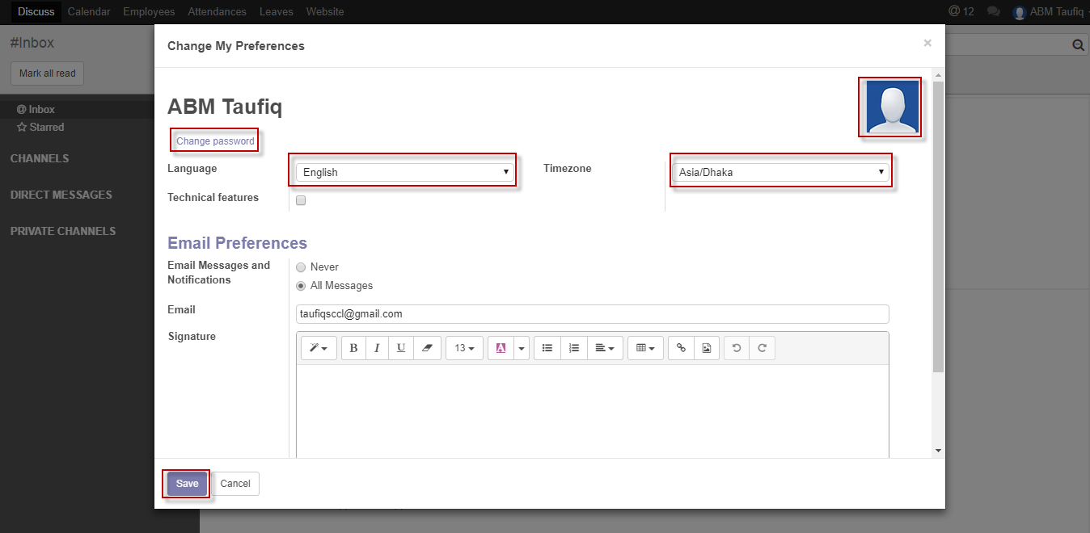

Figure: Edit Profile

Here we can change our own password. First we have to enter our Old Password then enter New Password & Confirm New Password. After entering the information click **Save**.

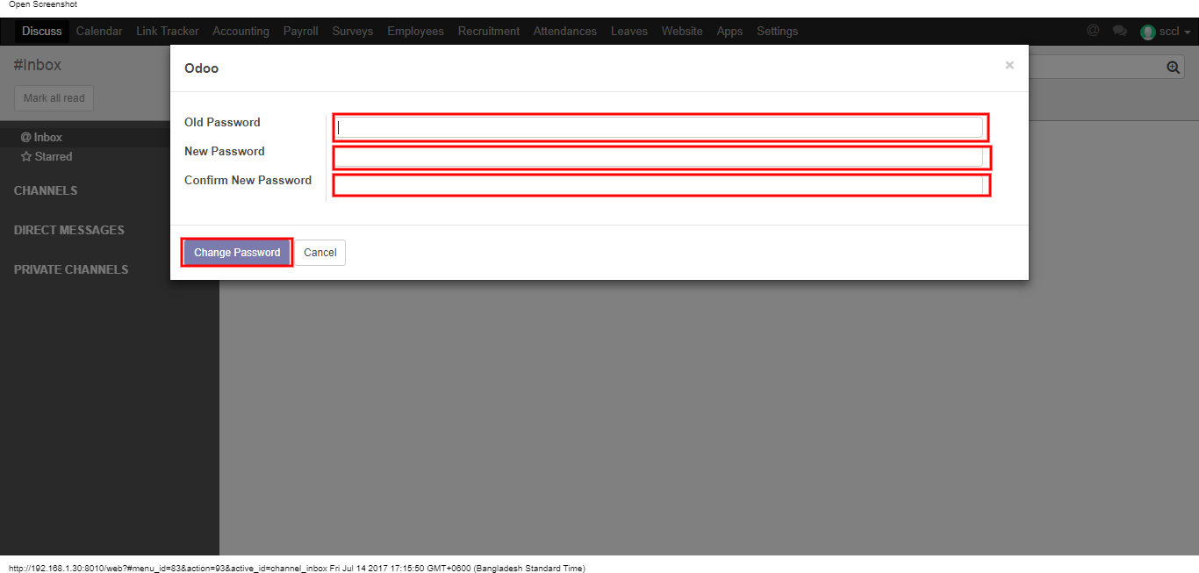

Fig: Change Password

## 1.5 Website Browse and Back to Home Page

Using the menu click **Website** and go to website page and to back click **Website button** then click any menu.

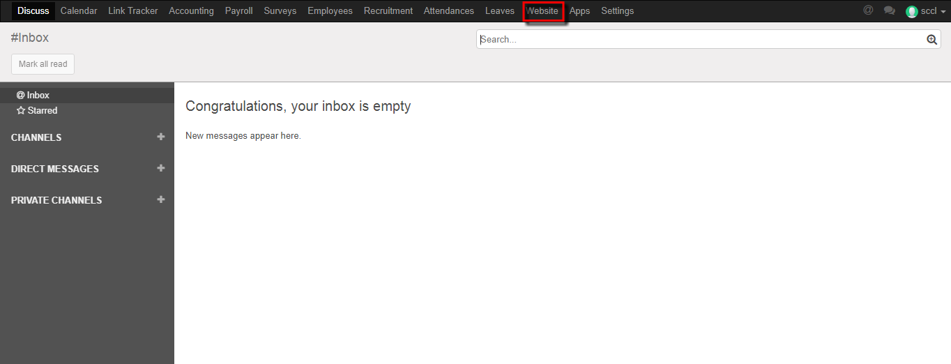

Fig: Go to Website Page

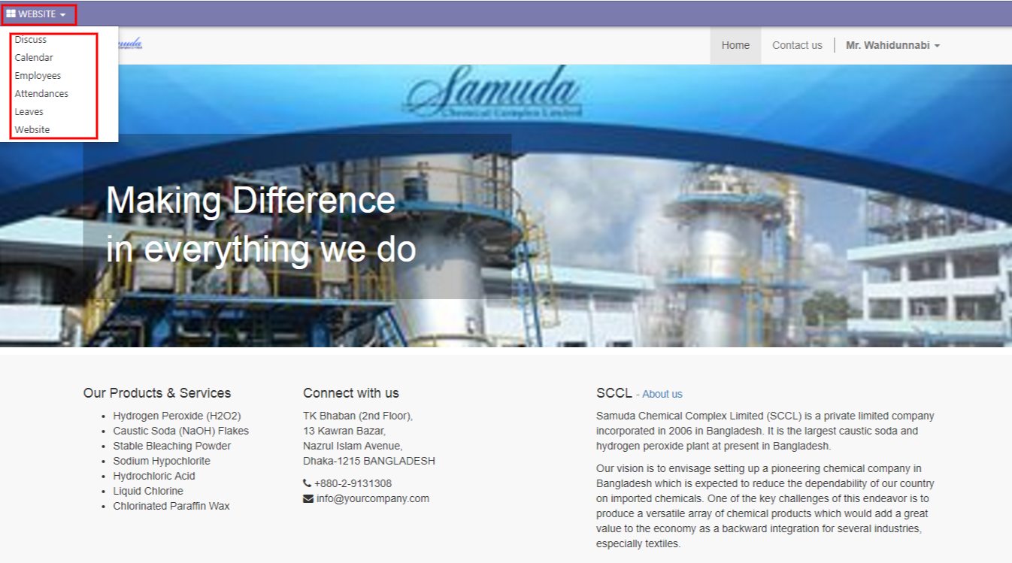

Fig: Back from Website Page

# 2. Leave Request

General user only can see his/her own leave information. Leave request, Leave allocation, short leave & leave summary.

## 2.1 Create Leave Request

For create a leave request we have to go leave menu then create a leave request.

Using the menu **Leave ‣ My Leaves ‣ Leave Request** click **Calendar** button.

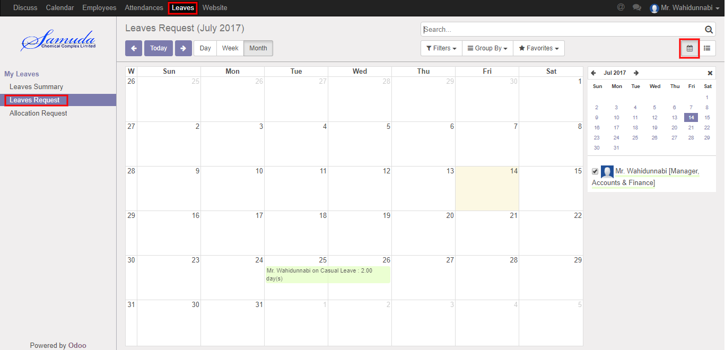

**Fig:** Leave Calendar View

Also we can see using the menu **Leave ‣ My Leaves ‣ Leave Request** click **List** button.

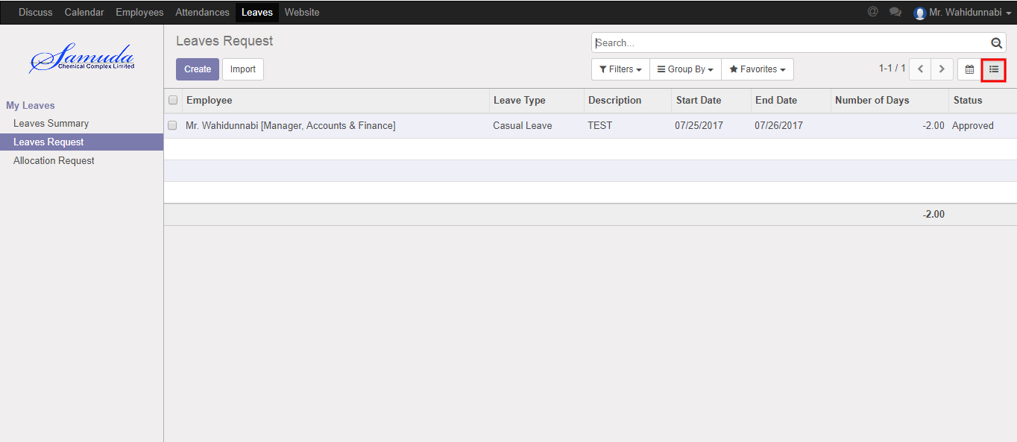

Figure**:** Leave List View

To create new Leave Request, Using the menu **Leave ‣ My Leaves ‣ Leave Request** click **Create**.

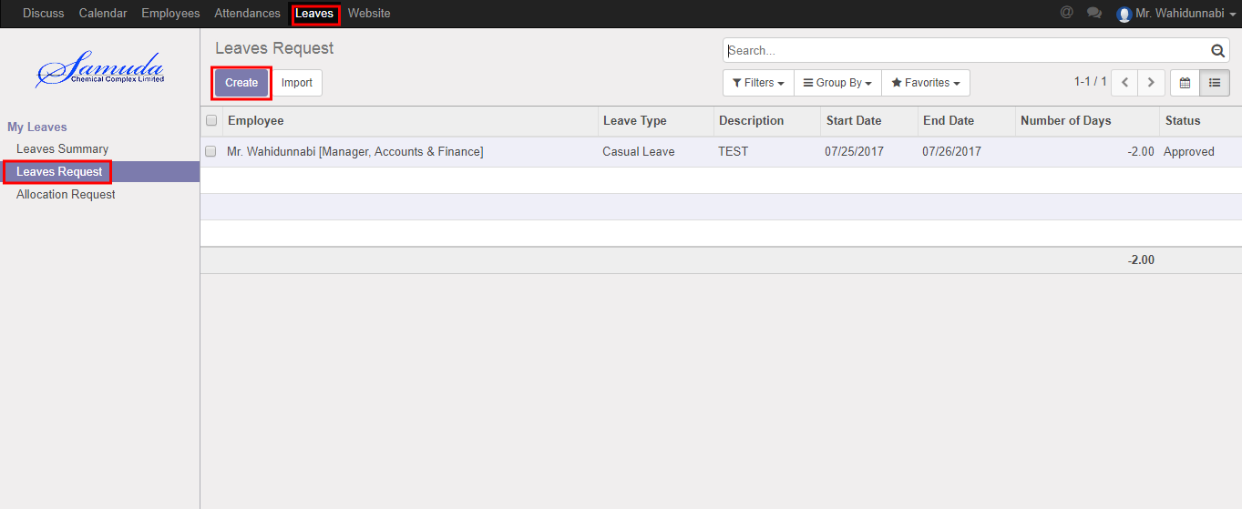

You can set the following information:-

**Description:** Enter some description.

**Leave Type:** Select a leave type.

**Duration:** Select duration of leave.

After entering the Leave Request information click **Save**.

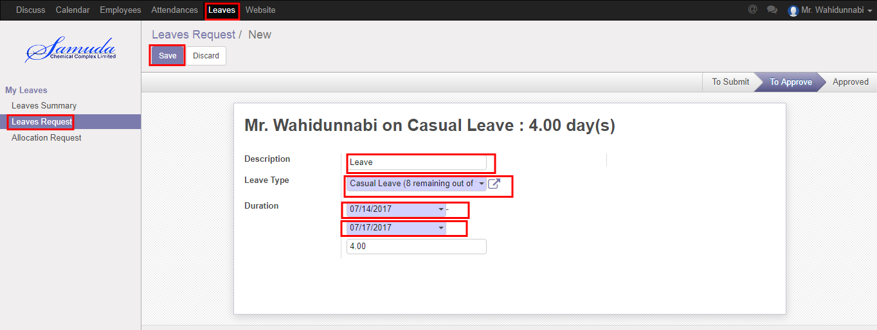

Figure: Create a Leave Request

After apply the leave request “Manager/supervisor” will get the notification. Unit HR can approve the leave request. He can update number of leave day(s) before approval. After Manager Approval, Unit HR will get notification. Unit HR Can Approve or Refuse the leave request. After that requested leave will finally approve.

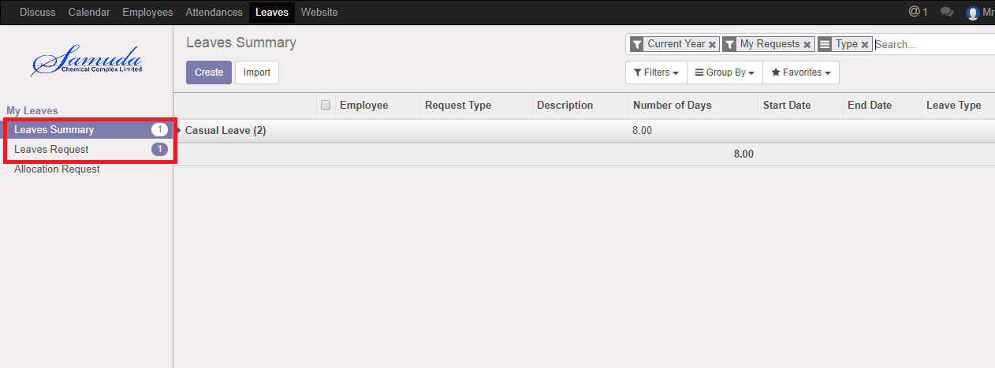

Figure: Leave Request Notification

## 2.2 Show Leave Summary

Using the menu **Leave ‣ My Leaves ‣ Leave Summary**.

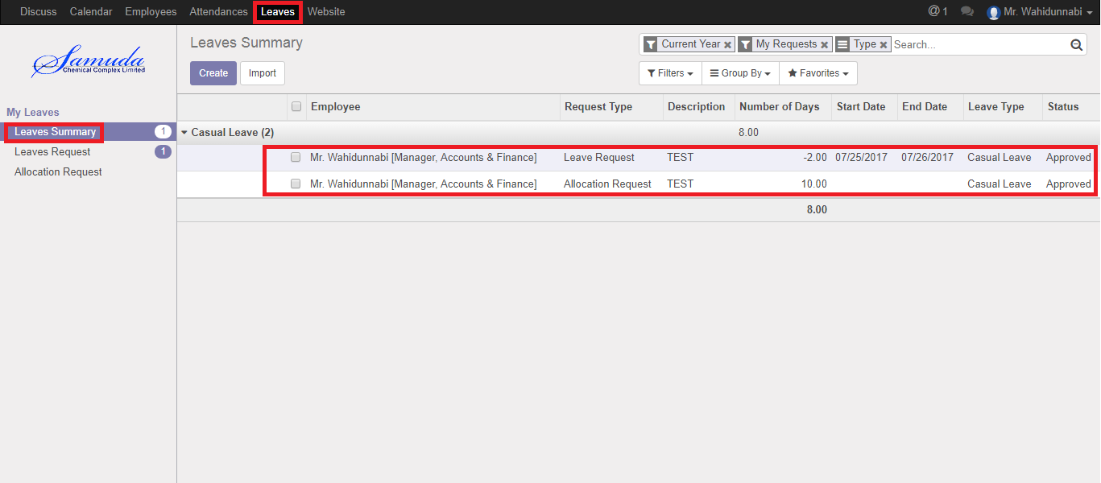

Figure: Leave Summary List View

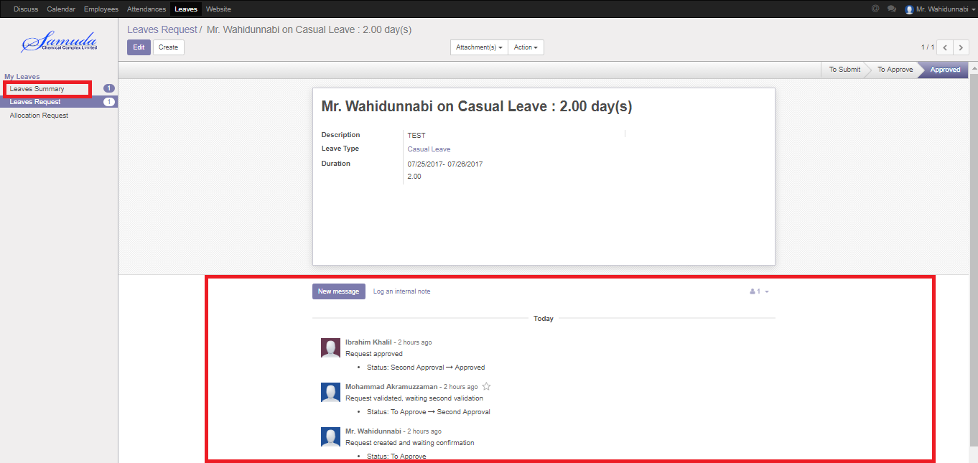

Figure: Leave Summary

## 2.3 Create Leave Allocation Request

For create a leave allocation request we have to go leave menu then create an allocation request.

Using the menu **Leave ‣ My Leaves ‣ Allocation Request** click **Create**.

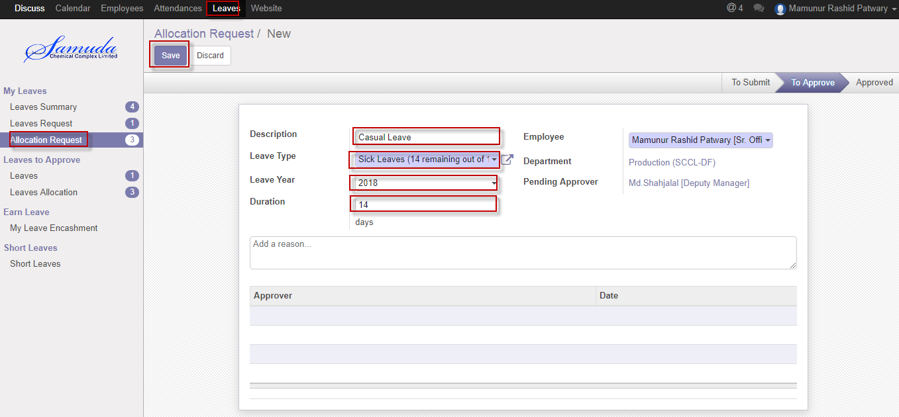

Figure: A Leave Allocation Request

After apply the leave allocation request “Manager/supervisor” will get the notification. Unit HR can approve or Refuse the leave allocation request. He can update number of day(s) before approval. After Manager Approval, Unit HR will get notification. Unit HR Can Approve or Refuse the leave allocation request. After that requested leave allocation will finally approve.

# 3. Short Leave Request

## 3.1 Create Short Leave Request

Short Leave is for urgent private business that occurs without notice. Short leave can be used for an emergency purpose. For create a short leave request, we have to go **Leaves** menu then create a Short Leave Request.

To create new Short Leave Request, Using the menu **Leave ‣ Short Leaves ‣ Short Leaves** click **Create**.

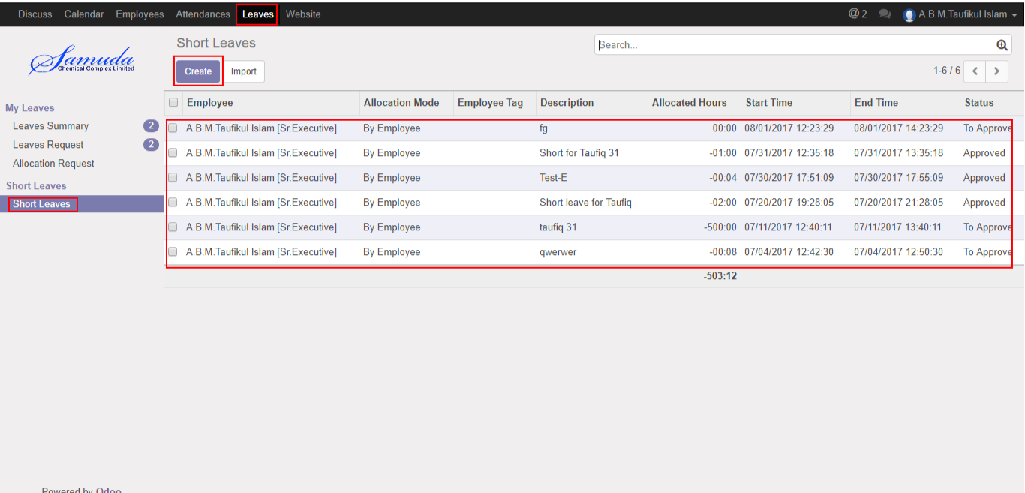

Figure: Short Leaves List View

You can set the following information:-

**Description:** Enter some description.

**Duration:** Select duration of leave.

After entering the Short Leave Request information click **Save**.

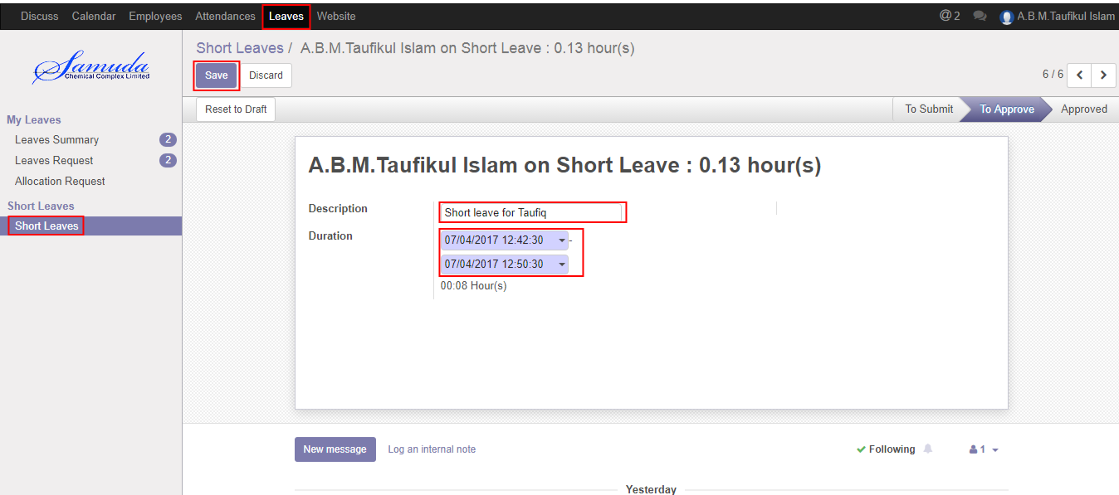

Figure: Create a Short Leave Request

After apply the Short leave request “Manager/supervisor” will get the notification. Manager/supervisor can approve or Refuse the short leave request. He can update number of Hour’s before approval. After Manager Approval, Unit HR will get notification. Unit HR Can Approve or Refuse the short leave request. After that requested short leave will finally approve.

# 4. Attendance

## 4.1 Create Manual Attendance

Sometimes employees work outside of office for this reason he/her can’t sign in or sign out. To solve this problem employee can request to Unit HR by this manual attendance process.

We can create manual attendance using the menu **Attendances ‣ Manual Attendances ‣ My Attendances** and click **Create.**

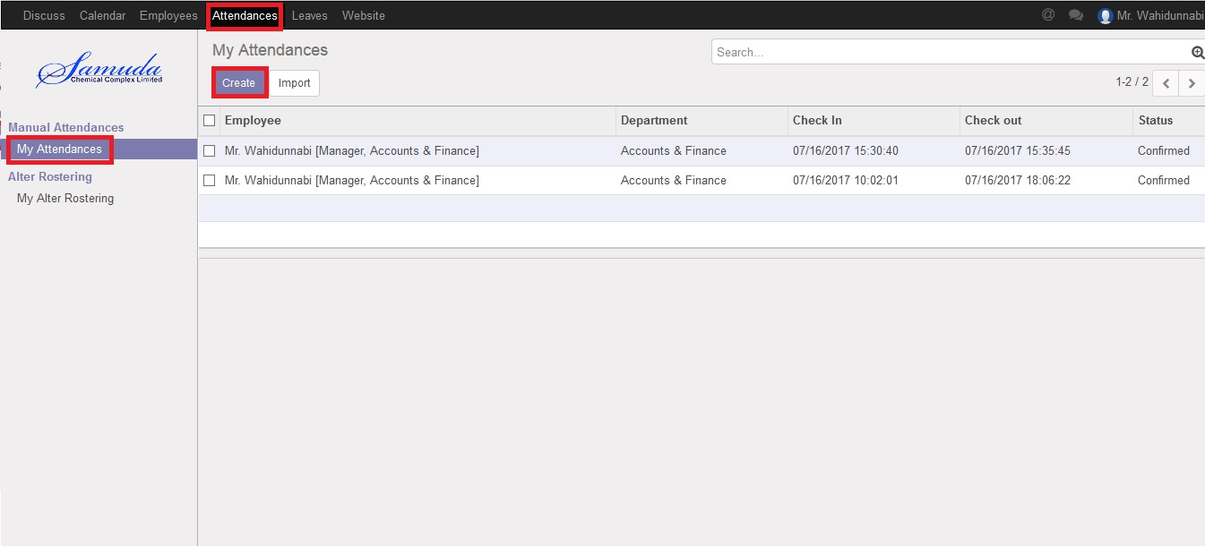

Figure: Manual Attendance List view

We need to set the following:-

**Employee**: An employee name.

**Department**: Select a department.

**Sign Type:** Select a sign type.

**Check In:** Work starting time.

**Check Out:** Work closing time.

After entering all information click **Save**.

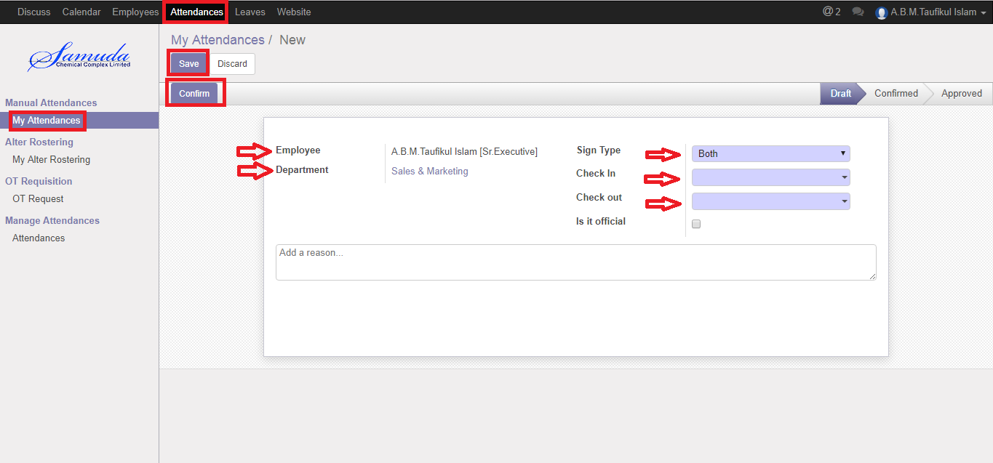

Figure: Create a Manual Attendance

After apply the Manual attendance “Manager/supervisor” will get the notification. Manager/supervisor can approve or Refuse the Manual attendance. He can update before approval. After Manager Approval, Unit HR will get notification. Unit HR Can Approve or Refuse the Manual attendance request. After that requested Manual attendance will finally approve.

## 4.2 Create Alter Rostering

Sometimes employees want to change his/her shifting and they want to request Unit HR . For solving this problem employee can request to Unit HR by this Alter Rostering process.

We can create alter rostering using the menu **Attendances ‣ Alter Rostering ‣ My Alter Rostering** click **Create.**

You need to set the following:-

**Employee**: An employee name.

**Alter Date:** A date for attendance.

**Duty Start:** A work stating time.

**Duty End:** A work closing time.

**OT Start:** A work over stating time.

**OT End:** A work over closing time.

After entering the alter rostering information click **Save**.

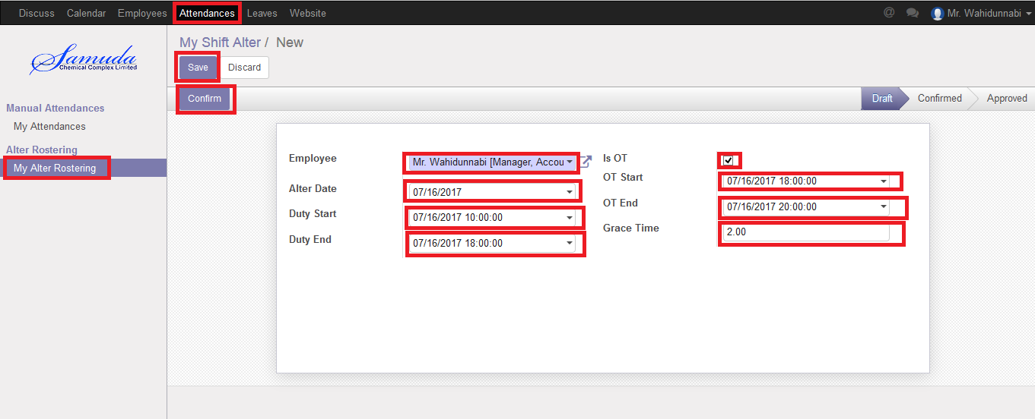

Figure: Create a Alter Rostering

After apply the Alter Rostering request Unit HR will see the request on Alter Rostering menu. Unit HR can approve or refuse the Alter Rostering request. After that requested Alter Rostering will finally approve. After final approval user can see on my Alter Rostering menu.

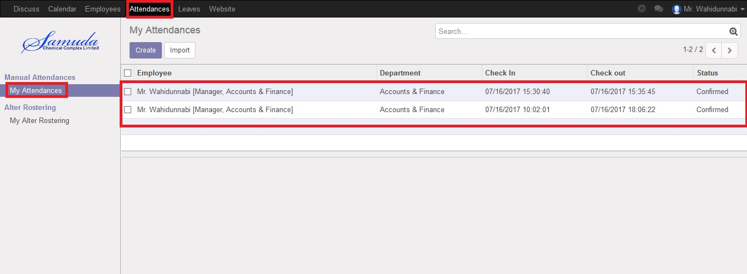

Figure: Alter Rostering Status

# 5. OT Requisition

## 5.1 Create a OT Request

Sometimes employees want to extra overtime work that’s why he/she have to request Manager. To solve this problem employee can request to Manager by this OT Requisition process.

We can create OT Request using the menu **Attendances ‣ OT Requisition ‣ OT Request** and click **Create.**

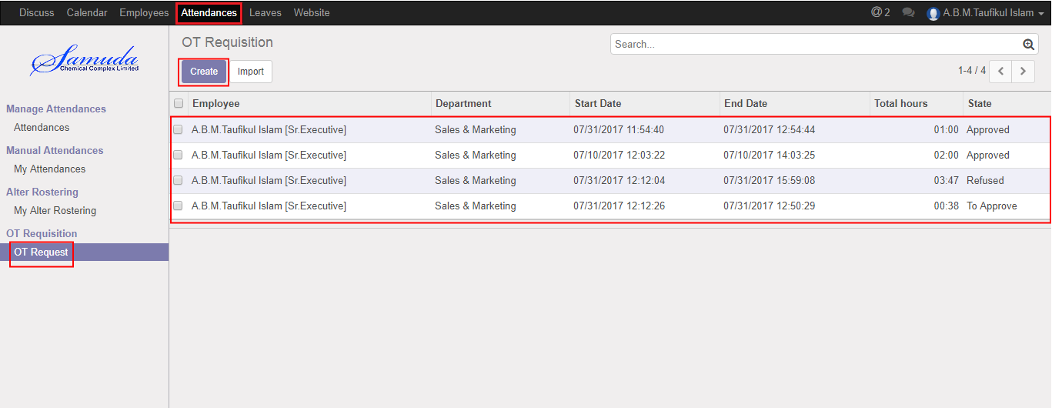

Figure: OT Request List view

We need to set the following:-

**Employee**: An employee name.

**Department**: Automatically select a department.

**Start Date:** Work starting time.

**End Date:** Work closing time.

After entering all information click **Save**.

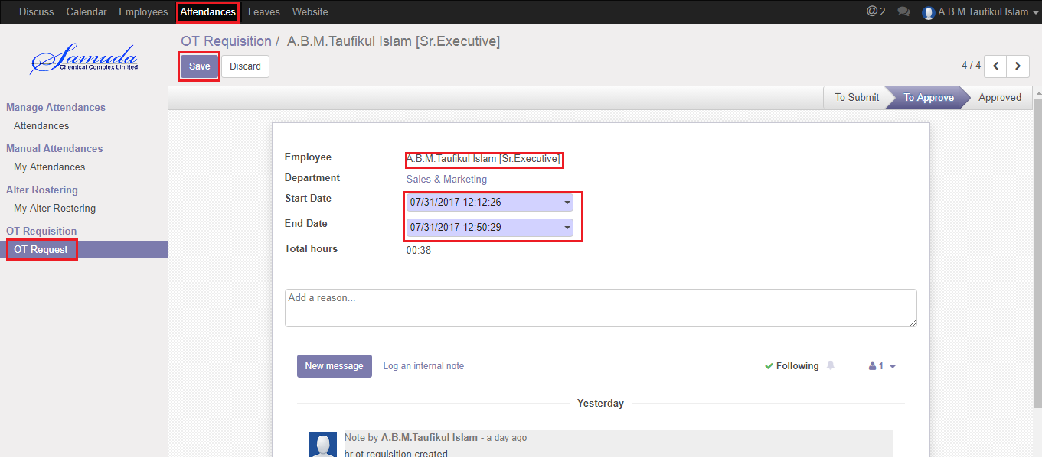

Figure: Create a OT Request

After apply the OT requisition “Manager/supervisor” will get the notification. Manager/supervisor can approve or Refuse the OT requisition. He can update before approval. After Manager Approval, Unit HR will get notification. Unit HR Can Approve or Refuse the OT requisition request. After that requested OT requisition will finally approve.

# 6. Employee

## 6.1 View employee

General user will view only under his/her employee hierarchy wise.HR manager can set all employee information. User can login with his/her own account then will view employee hierarchy.

We can view employee using the menu **Employee ‣ View**

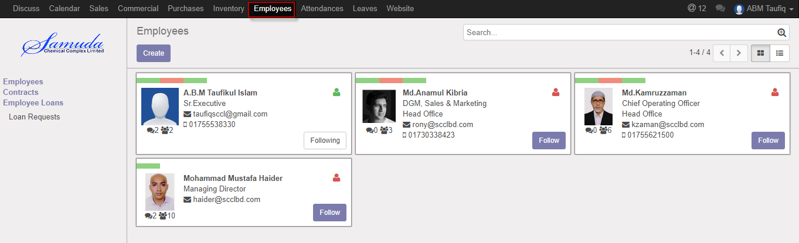

Figure: View employee

# 7. Mobile bills

## 7.1 View mobile bills

General user will view his/her own mobile bills.HR manager can set mobile bills. User can login with his/her own account then will go profile & open mobile bill portion

We can view Mobile bills using the menu **Employee ‣ Mobile bills**

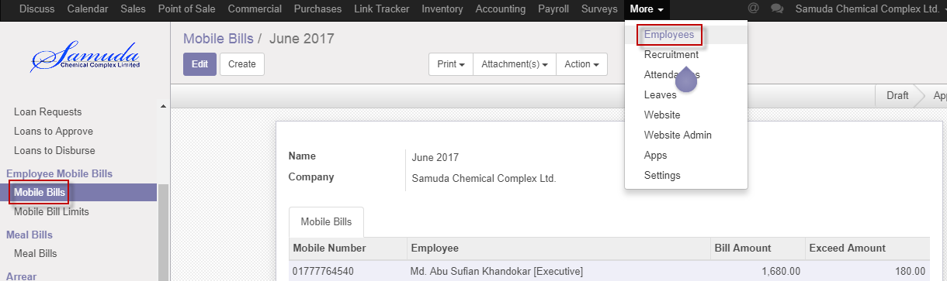

Figure: View mobile bills

# 8. Mobile bill limits

## 8.1 View mobile bill limits

General user will view his/her own mobile bill limits.HR manager can set mobile bill limits. User can login with his/her own account then will go profile & open mobile bill limits portion

We can view Mobile bill limits using the menu **Employee ‣ Mobile bill limits**

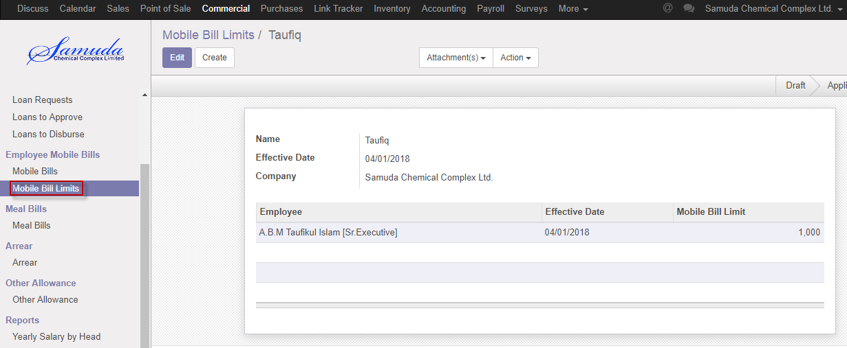

Figure: View mobile bill limits

# 9. Contracts

## 9.1 View Contracts

General user will view his/her own contracts.HR manager can set contracts. User can login with his/her own account then will go contracts.

We can view contracts using the menu **Employee ‣ Contracts**

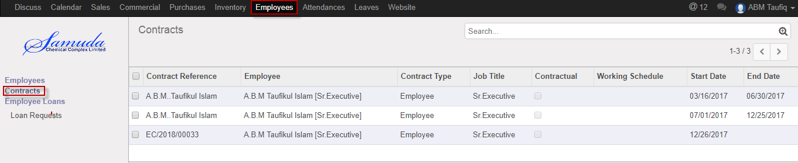

Figure: View contracts

# 10. Employee IOU

## 10.1 View employee IOU

General user will view his/her own IOU.HR manager can set IOU. User can login with his/her own account then will go employee IOU.IOU is short time loan taking from HR end. Which has no installment just has a short info.

We can view employee IOU using the menu **Employee ‣ employee IOU**

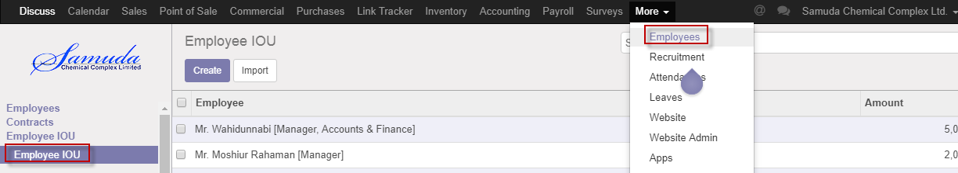

Figure: View employee IOU

# 11. Loan request

Some time employee may require loan then user can do Loan request and HR manager will approve Loan request.

## 11.2 Create Loan request

For create a Loan request we have to go Employee menu then create a loan request.

Using the menu **Employee ‣Employee loans ‣ Loan Request** click **Create** button.

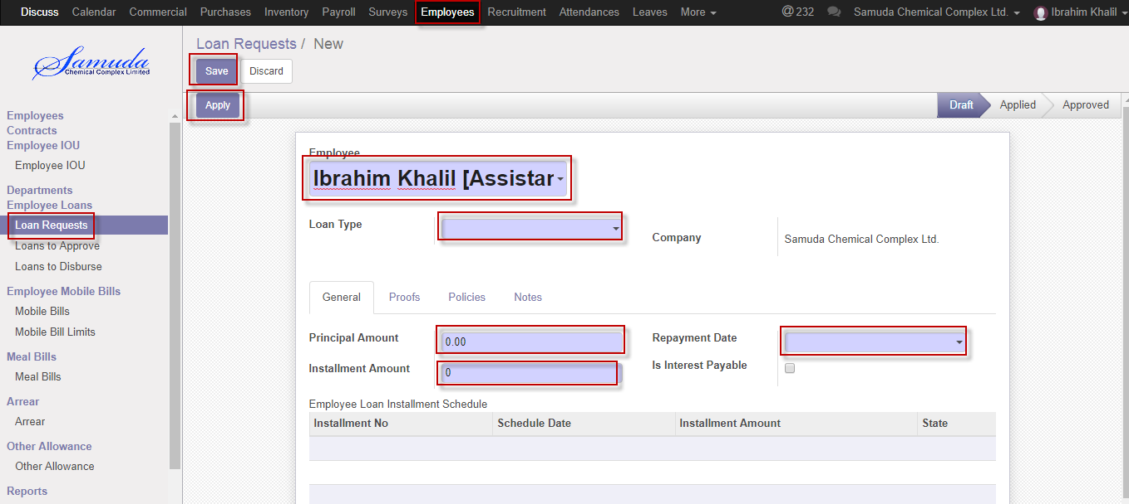

Figure: Create Loan request

You can set the following information:-

**Employee:** Select employee

**Loan Type:** Select a loan type.

**Principal amount:** Enter principal amount.

**Installment amount:** Enter installment amount

**Repayment date:** Select repayment date.

After entering the Loan Request information click **save**.

We can view Loan request using the menu **Employee ‣ Loan request**

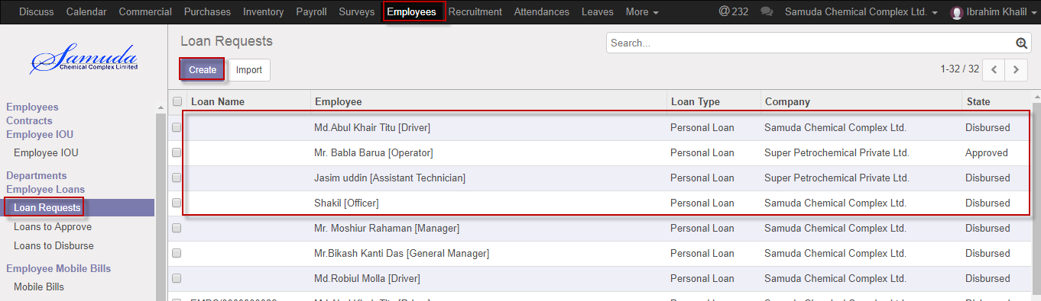

Figure: Loan request list view